Introduction to Hypervisors and VMs, Xen or KVM, Introduction to

Containers: Docker, installation and deployment.

Installation and Deployment of Hypervisor (Type 2)

A type 2 hypervisor enables users to run isolated instances of other operating

systems inside a host system. As a Linux based OS, Ubuntu supports a wide range

of virtualization solutions.

Aside from popular third-party apps, such as VirtualBox and VMWare, the Linux

kernel has its own virtualization module called KVM (Kernel-based Virtual

Machine).

Procedure:

Step 1: Install KVM Packages

1. First, update the repositories:

sudo apt update

2. Then, install essential KVM packages with the following command:

sudo apt install qemu-kvm libvirt-daemon-system libvirt-clients bridge-utils

Step 2: Authorize Users

1. Only members of the libvirt and kvm user groups can run virtual machines.

Add a user to the libvirt group by typing:

sudo adduser ‘username’ libvirt

Replace username with the actual username.

Step 3: Install Virtual Manager

1.Type the command in the terminal

sudo apt install virt-manager

2. Type Y and press ENTER. Wait for the installation to finish

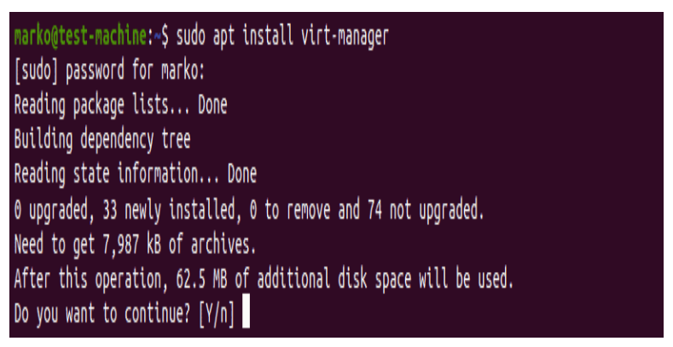

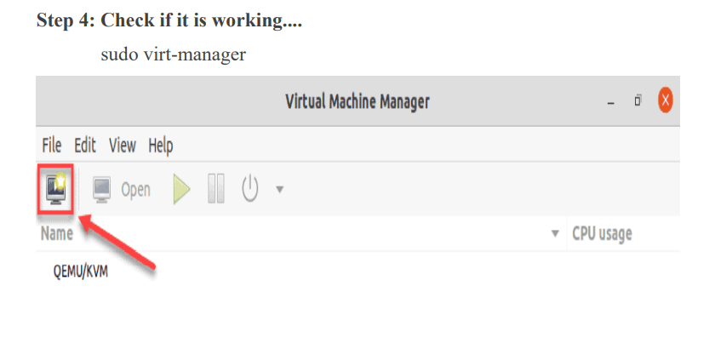

Installation and Deployment of Docker

Procedure:

1)Set up the repository

Step 1: Update the apt package index and install packages to allow apt to use

a repository over HTTPS:

sudo apt upgrade

sudo apt-get install \

apt-transport-https \

ca-certificates \

curl \

gnupg \

lsb-release

Step 2: Add Docker’s official GPG key:

curl -fsSL https://download.docker.com/linux/ubuntu/gpg | sudo apt-key add

Step 3: Use the following command to set up the stable repository

echo \

> "deb [arch=amd64 signed-by=/usr/share/keyrings/docker-archive-keyring.gpg]

https://download.docker.com/linux/ubuntu \

> $(lsb_release -cs) stable" | sudo tee /etc/apt/sources.list.d/docker.list >

/dev/null

2)Install Docker Engine

Step 1:Update the apt package index, and install the latest version of Docker

Engine and container, or go to the next step to install a specific version:

sudo apt-get update

Step 2: Install docker

sudo apt-get install docker-ce docker-ce-cli containerd.io

Step 3: Check that whether it is running

sudo systemctl status docker

Step 4: To view different docker commands

docker

Step 5: Docker information

sudo docker info

Step 6: Verify that Docker Engine is installed correctly by running the helloworld image.

sudo docker run hello-world

